Traditions that Shape Culture



Local activities in Turkey

Ihlara Valley

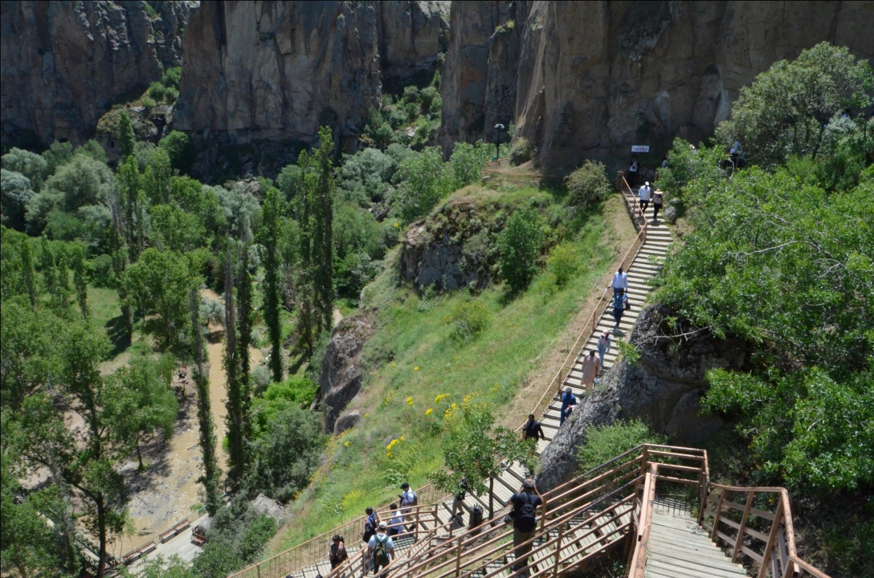

Ihlara Valley is a deep river canyon in Western Cappadocia with stunning nature and medieval cave churches.ıhlara valley was visited by the students

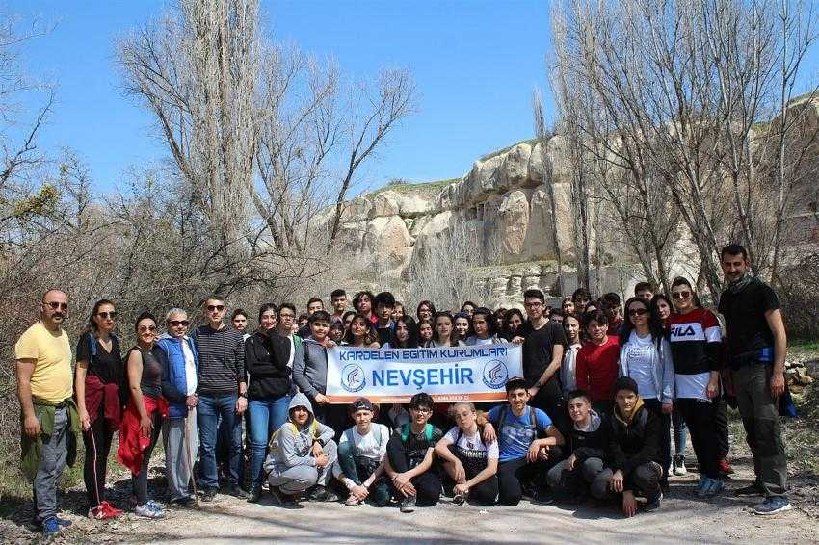

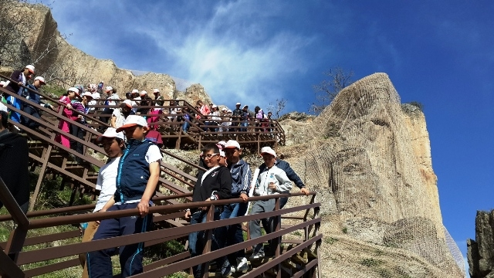

Derinkuyu underground city

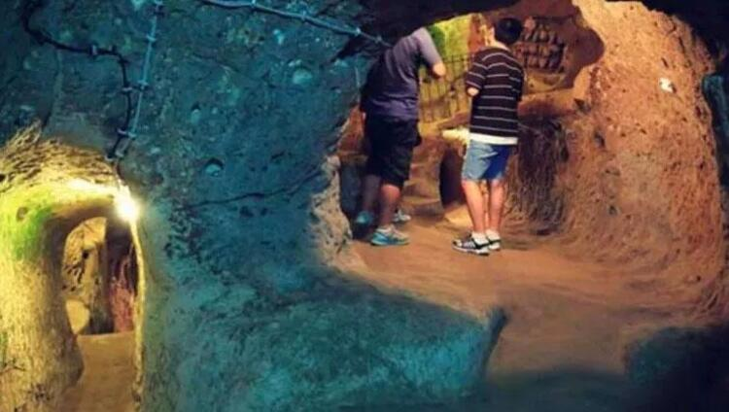

Within the framework of world cultural heritage

Derinkuyu underground city was walked by the Kardelen College students and teachersThere were large stone rollers used to close the tunnel for security reasons at the entrance of the tunnels.That was entartaining.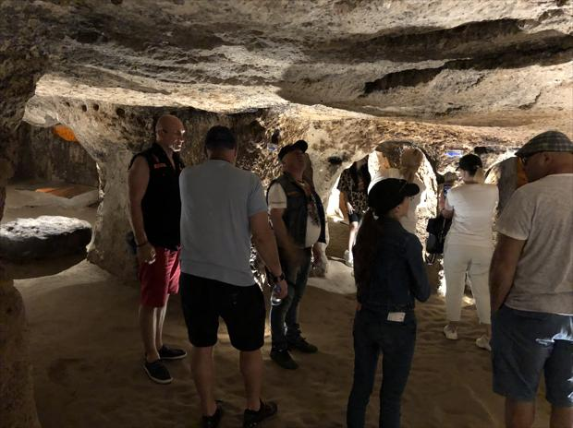

Zemi Valley



Within the framework of world cultural heritage

Zemi Valley walked by the Kardelen College students and teachers.

Göreme open air museum

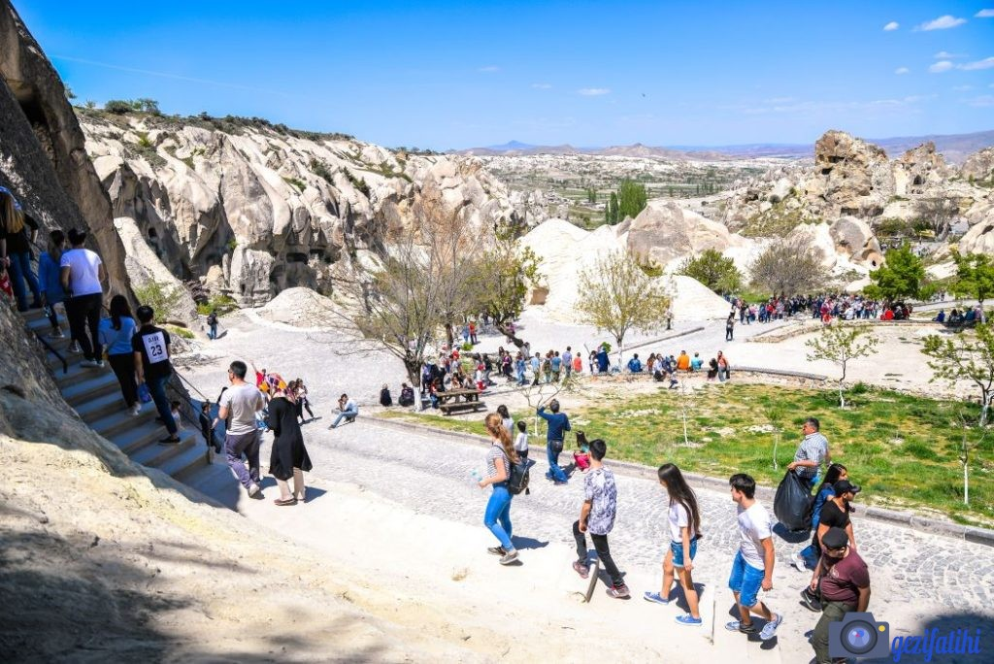

Göreme open air museum was visited to explore the cultural heritages around us. Churches in all rock blocks, chapels, dining and living spaces were amazing.

